**Elastic Block Storage (EBS)**

When you are creating an instance, we will select the instance type in these field we will see the instance storage field like as fallows.

Two types of storages

1)EBS

2)Instance Store

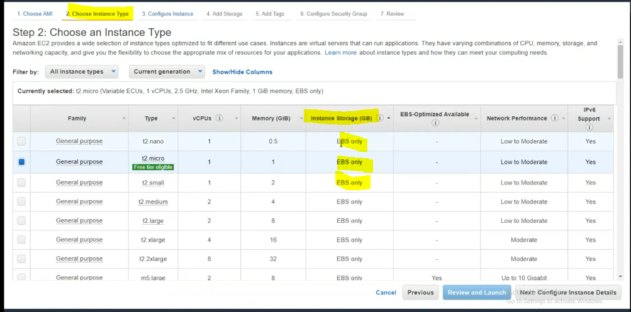

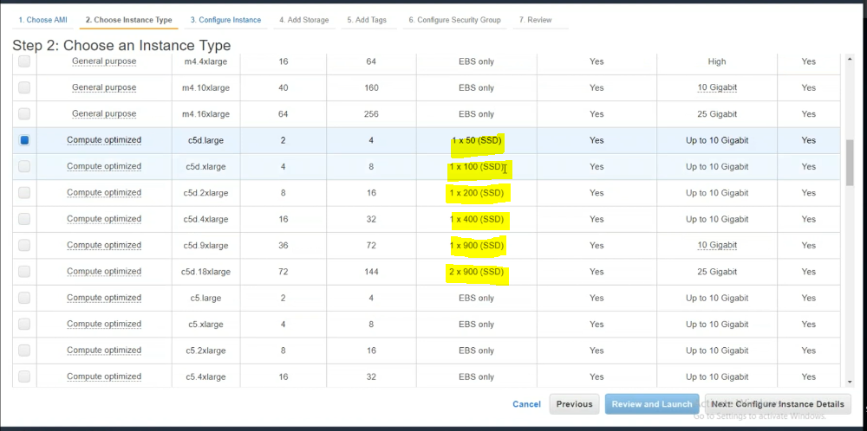

**1)EBS (Elastic Block Storage)**

Advantages:

1)Its permanent Storage🡪data will be present until you delete the data.

2)You can increase the drive volumes.

3)Different types of EBS volumes are available like SSD, SAS and SATA.

4)You can remove volume from one server and attach to another server.

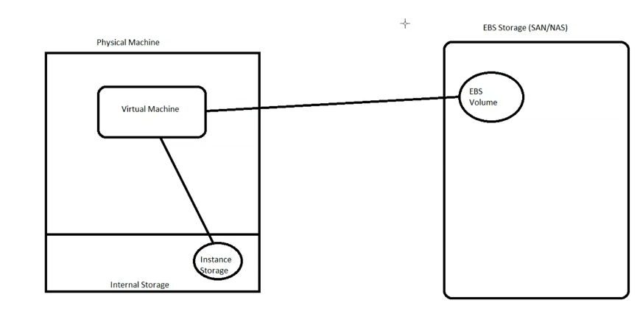

**2)Instance storage**

1)Its temporary storage.

2)Its fixed

3)One type of Storage is available

4) You cannot remove IS volume from one server and attach to another server.

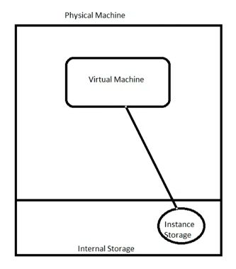

For all type of instances IS is not available. If its available for some types means both EBS and IS are there to use this type. Whatever given SSD type storage if you can stop and start the instance data will be lost.

We can select the m3.medium

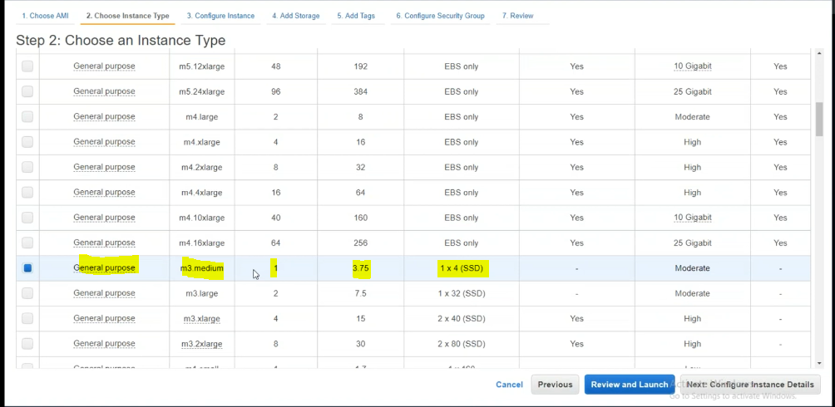for root its fixed EBS volume for IS we need to add volume

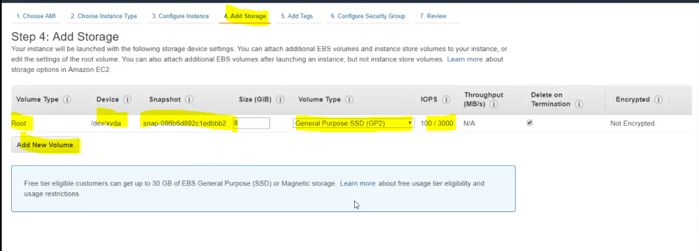select volume type as instance store.

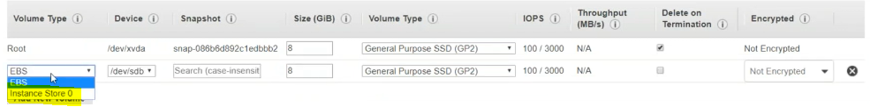

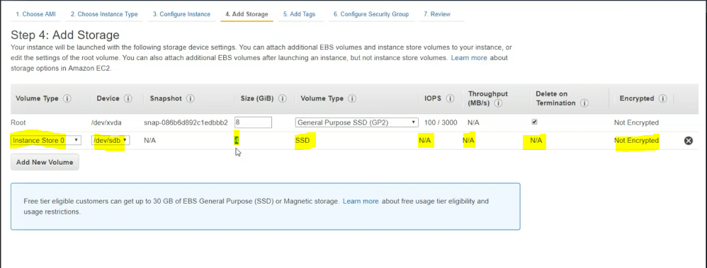rest all are same what we have used while creating an instance.

Instance is created

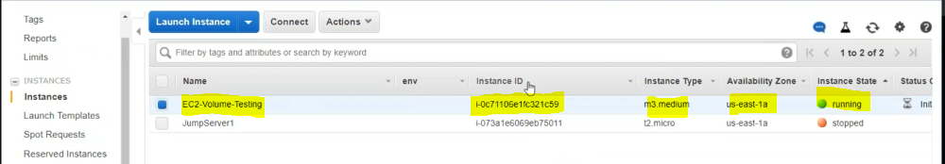

For how many disk are connected to our instance.

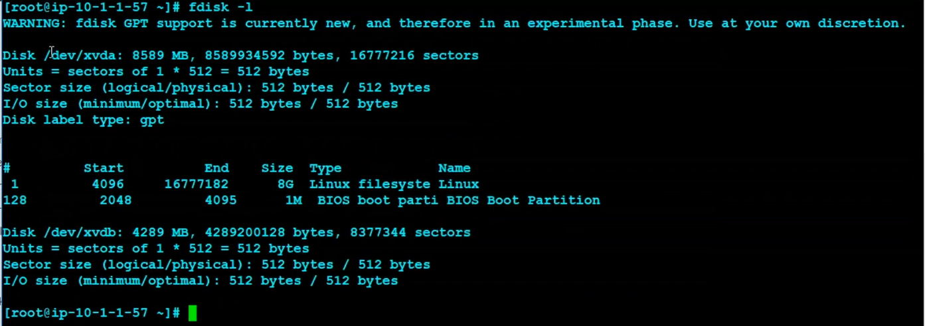

EBS volume

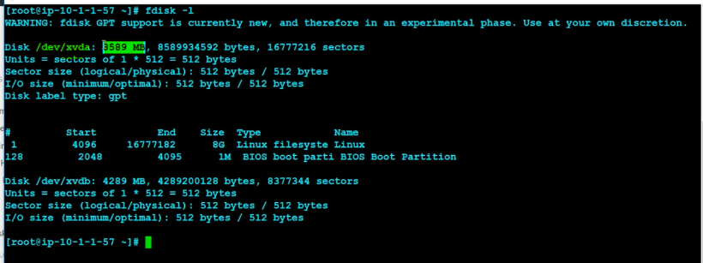

IS volume

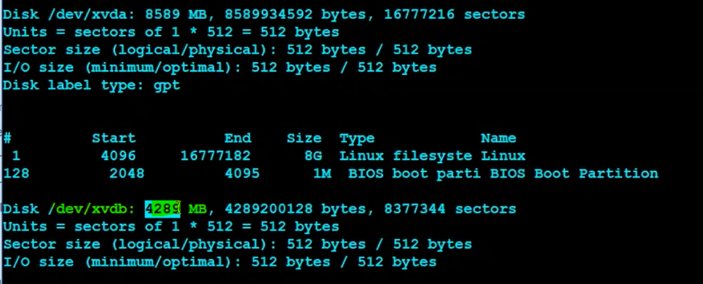

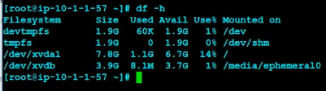

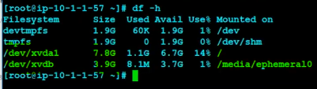

I will go to this path /media/ephemeral10 to create some directories

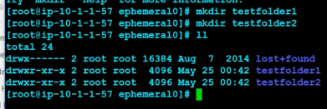

In testfolder1 we will create one empty file using touch command.

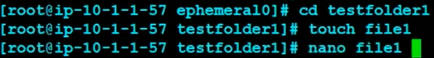

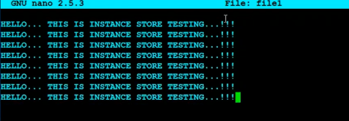

Ctrl O for saving

Ctrl X for Quit.

Copying file1 to file2,file3,file4 and file5 like as fallows

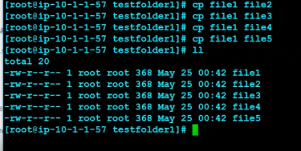

Same files I am copying into testfolder2 like as fallows.



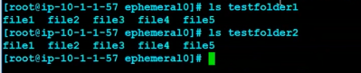

Now I am assign new volume and format that volume and need to copy same files then I will stop the instance and start the assignment will see the data will be present in IS volume or not.

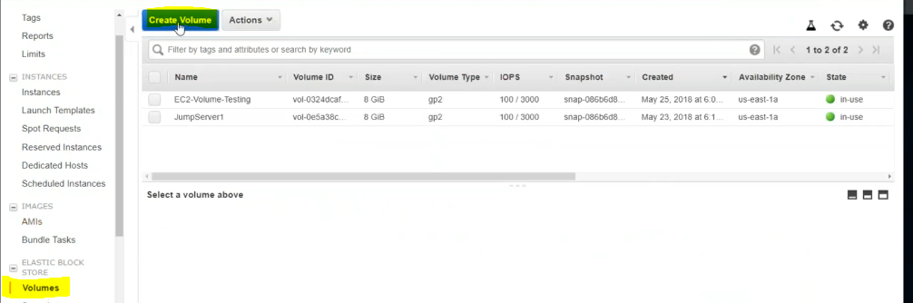

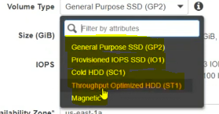

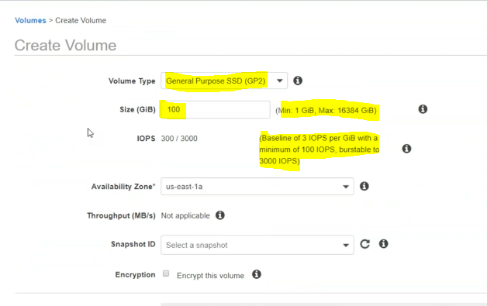

Volume type:  
1) gp2🡪 1Gb to 16TB ( per GB 3 IOPS minimum 100 IOPS and maximum 100 IOPS)

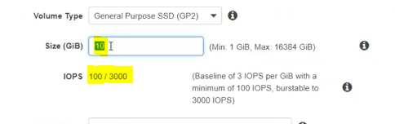

If I need to calculate the disk performance by using InputOutputPerSeceond (IOPS). If IOPS number is increase disk performance also increases.

2)Provisioned IOPS SSD (IO1)

4GB to 16TB (per GB minimum 100 IOPS and maximum 32000 IOPS

You can set IOPS manually in this volume type but it’s costly.

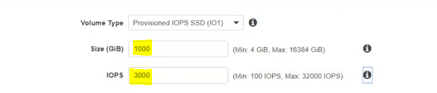

2)Cold HDD (SC1)

5 GB to 16 TB

IOPS is not applicable.

12MBps per TB

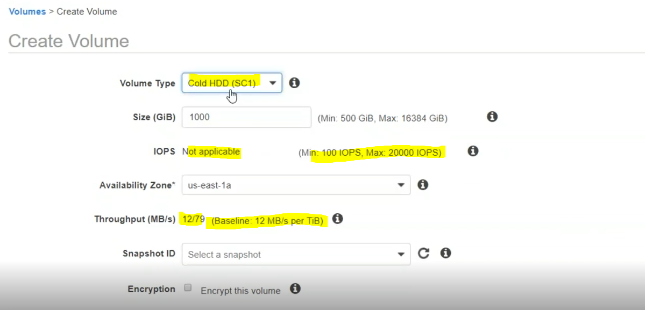

Less throughput

3)Throughput optimized HDD (ST1)

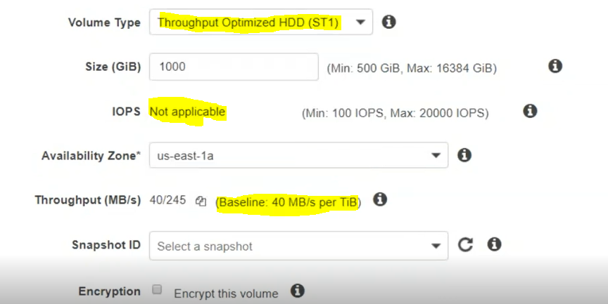

Less throughput

4)Magnetic

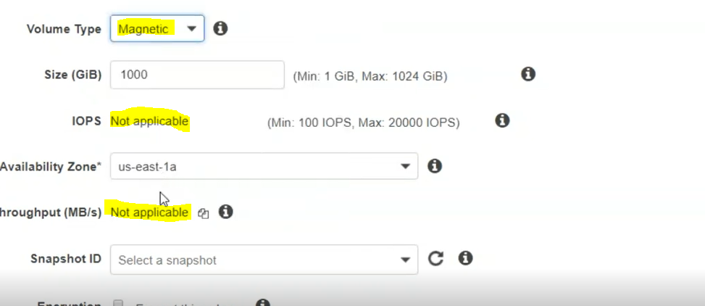

I thought that after some days Cold HDD and Throughput HDD will remove and magnetic.

Let we take 5GB general purpose create volume

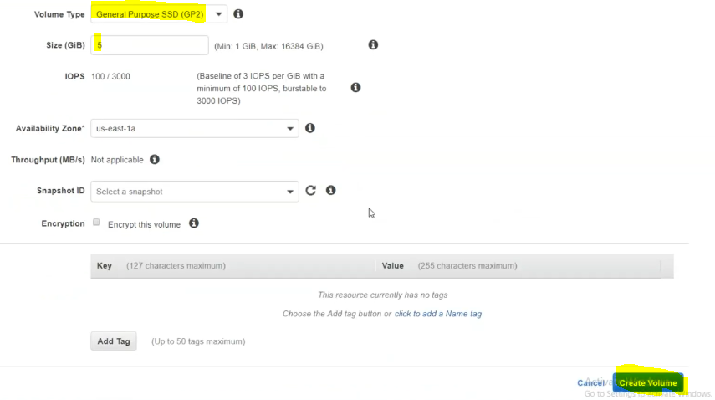

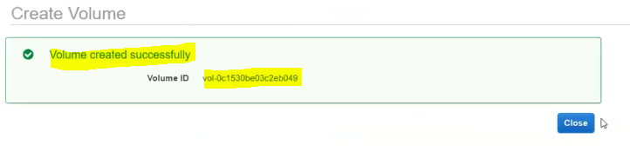

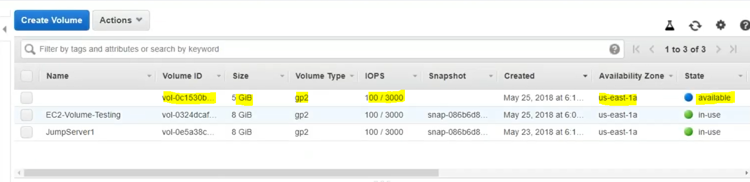if volume is not assigned to anyone it shows available only.

Now we are attaching this volume to our created test instance.

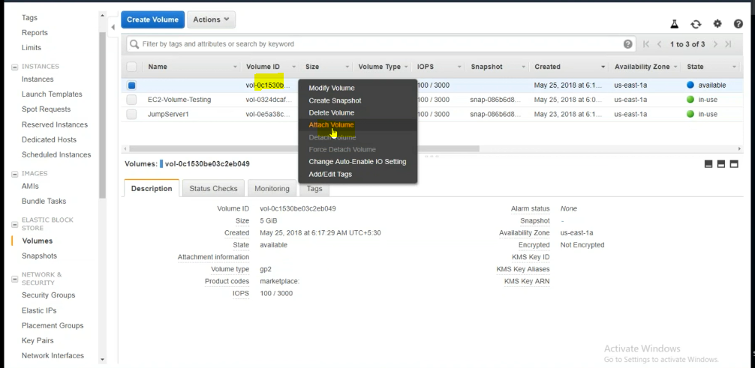

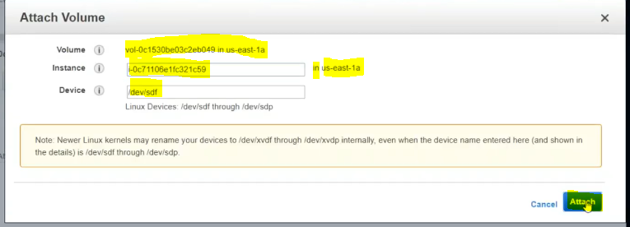

After attaching this volume to instance, it will show in use.

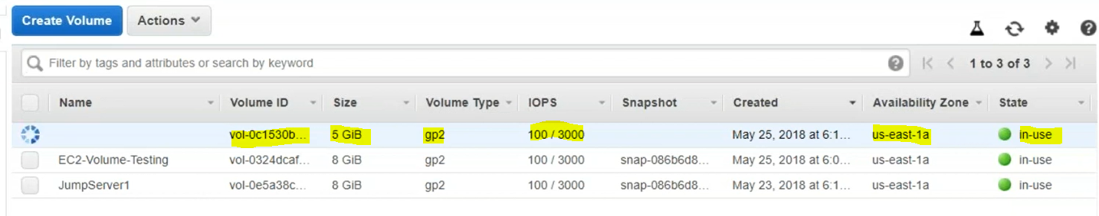

Given name in real time environment for how is using this volume knowing purpose.

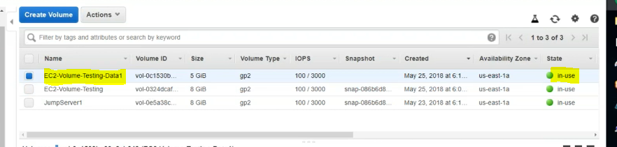

Now we will test if this volume is assigned to test instance or not.

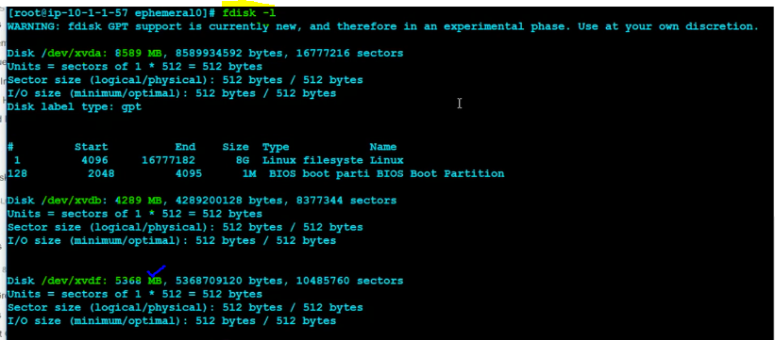

Now we are using Linux commands to partitions and usages

Now we need to format this volume and do partitions for usage.

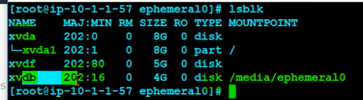

Disk partitions in windows like

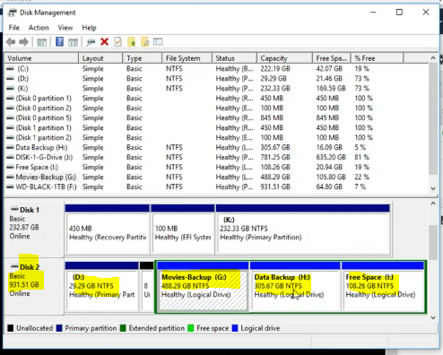

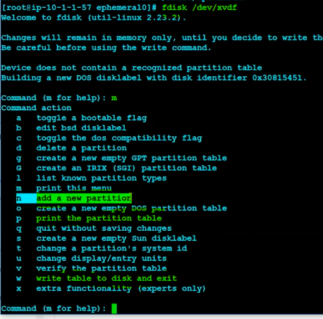

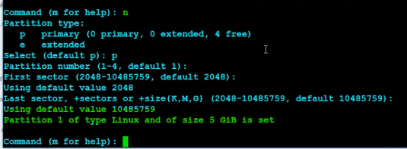

Finally use command n for saving

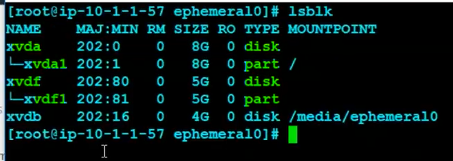now we are creating the file system the only we can use it.

File system is created

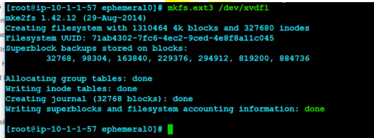

Now we are mounting the file system

We are creating one directory and mounting this file system to this directory





Now you can see created mount point .

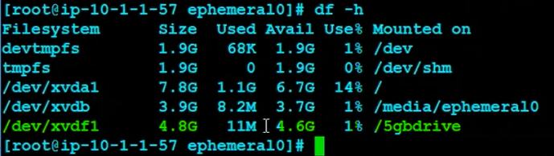now we are copying the files that are present under /media/ephemeral10 to /5gbdrive

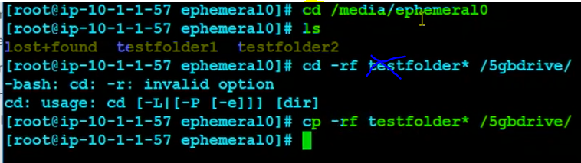

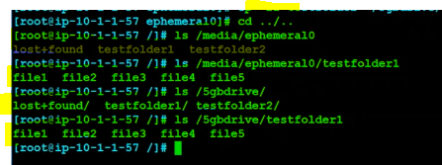

Now I will shutdown and start the instance will see instance store data will be present or not.

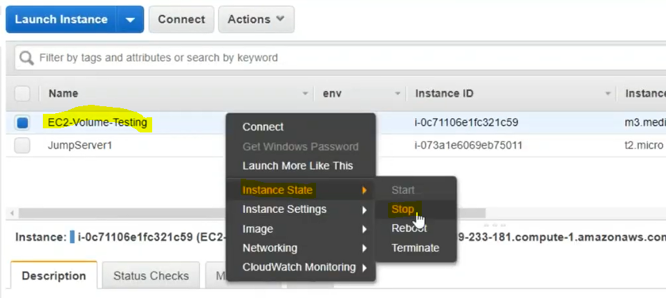

Note:

Previously per hour billing is there, but now if you shut down and start the instance for 4times in an hour they will calculate it as 4hours bill you accordingly if you stop and the start the instance billing will calculate based on hours.

Now again start the instance

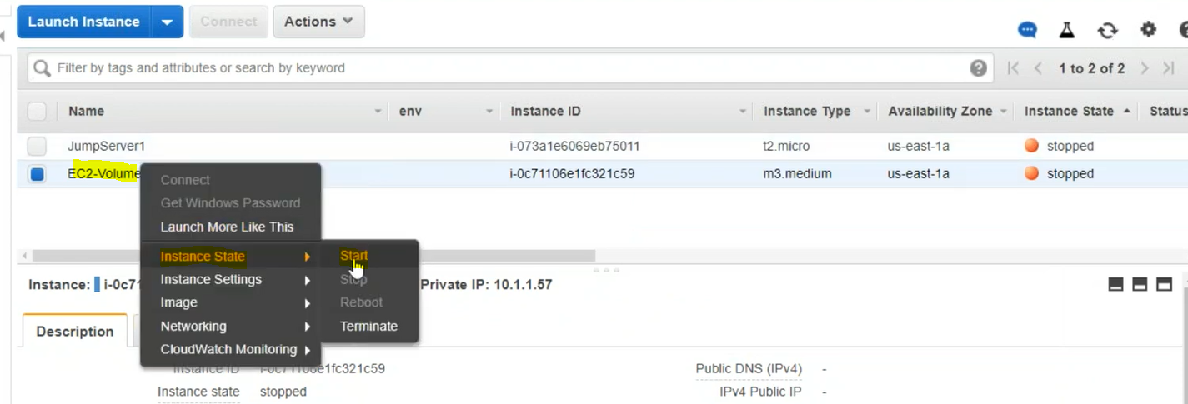

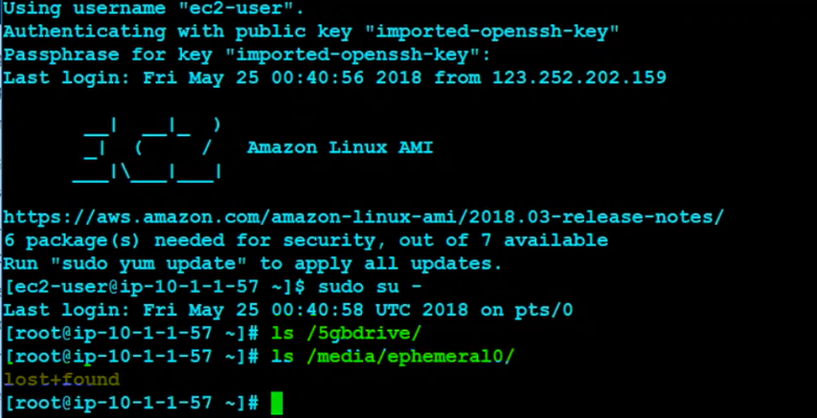

/5gbdrive is not available and no data shown in previous command.

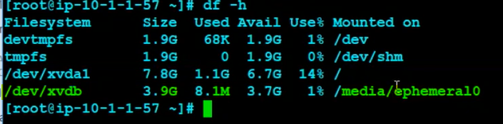

In Linux mount the mount point then only it will visable.



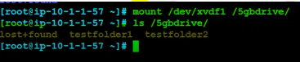

Initially it will be in memory after we are stop aand start the instance it will be gone again we need to mount the mount point.

I need to maintain this mount point permanently like as fallows.



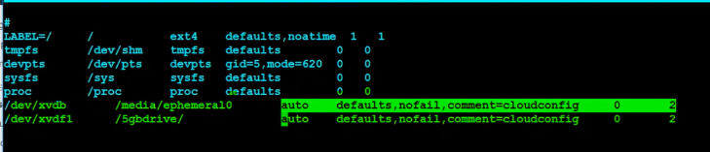

Ctrl O for saving

Ctrl X for quit.

Now you can restart or reboot also this mount point will remains same.

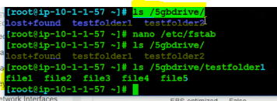

Data remains same in EBS volume where as in Instance store data will be lost.

Then what’s the purpose of giving Instance store as volume means.

Suppose you need to design an Db server let us assume you require the following volumes.

OS 🡪EBS GP2

Data-🡪EBS IO1-🡪for high performance

Logs🡪EBS IO1🡪for high performance

Temp DB 🡪Instance Store

Backup 🡪COLD SC1/ST1/magnetic

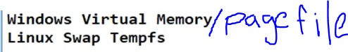

For old generations may have Instance store I think check in instance

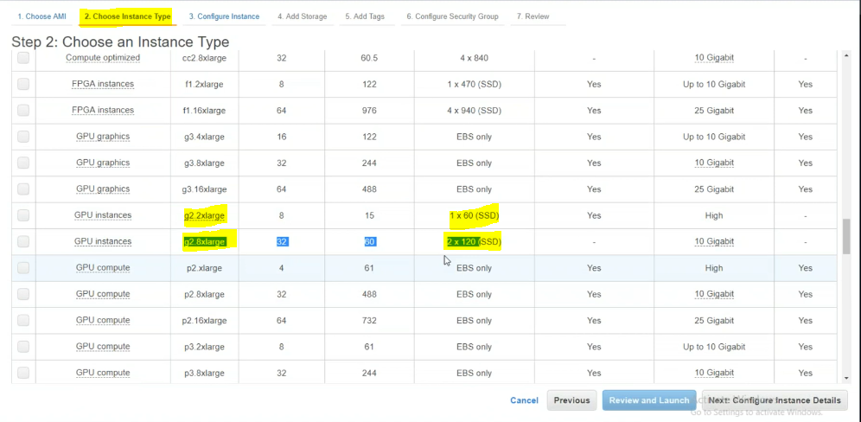

Unmount drive



Now we need to take snapshot of this volume

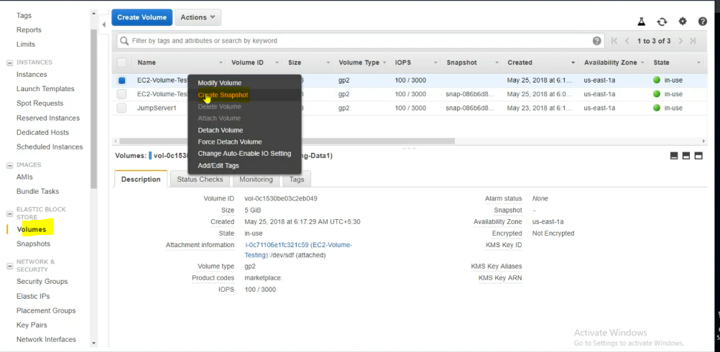

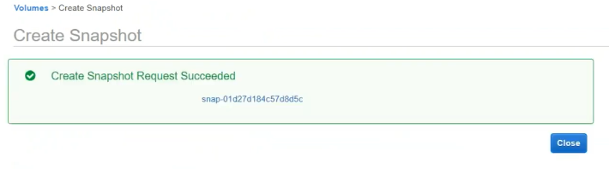

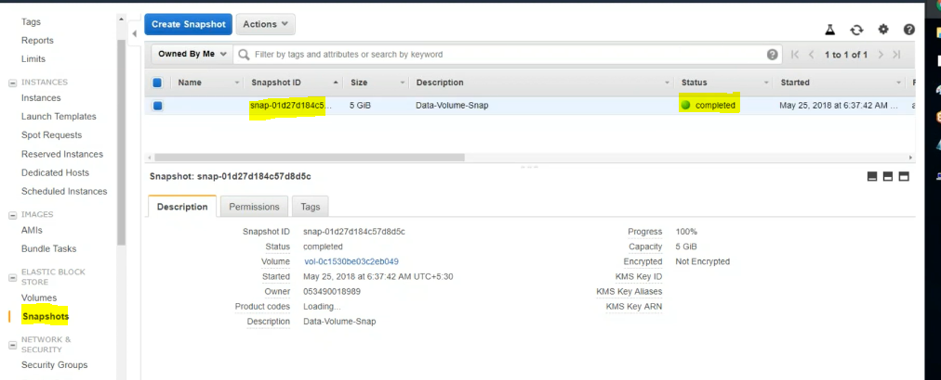

Detaching the volume

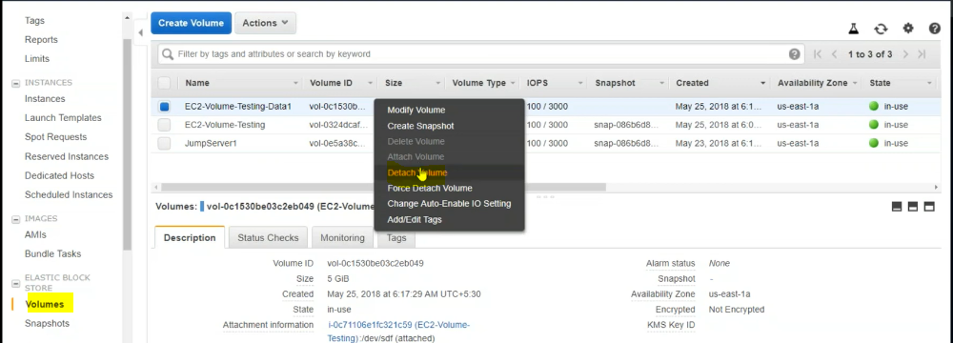

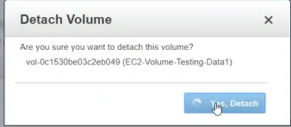

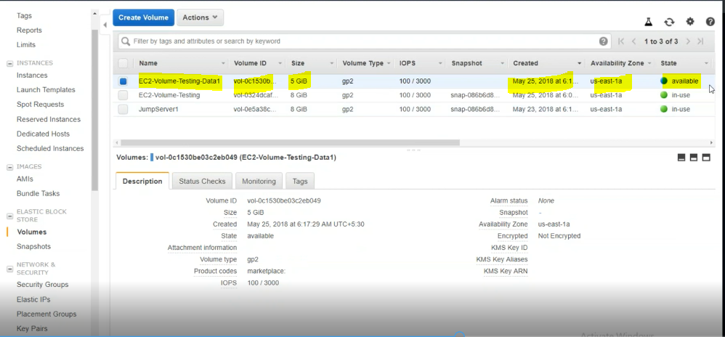

Now if you want to use for some other instance also.

Modefy volume:

I need to extend the volume but check whether your operation system is capable or not you need to create lvm before extending the volume.

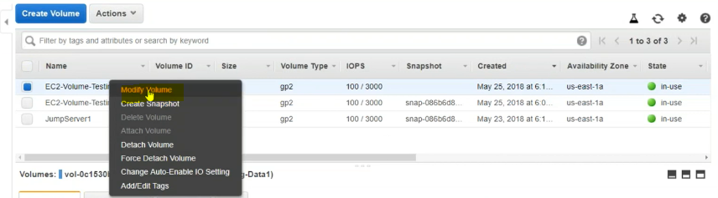

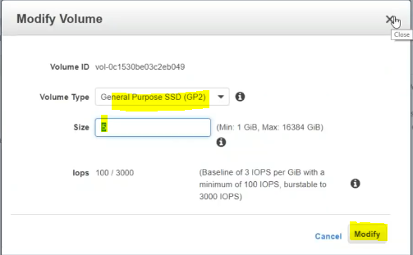

Delete the volume

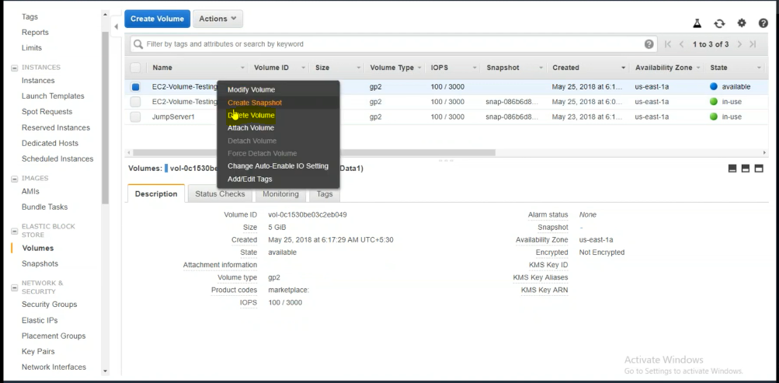

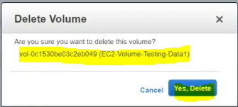

If I want to create a volume again

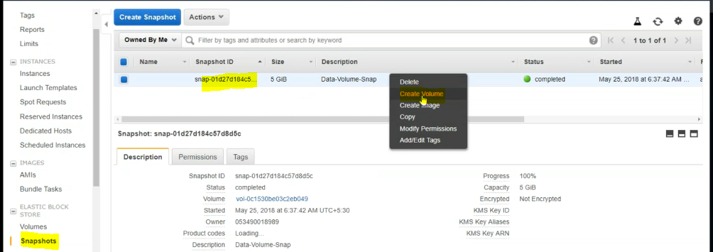

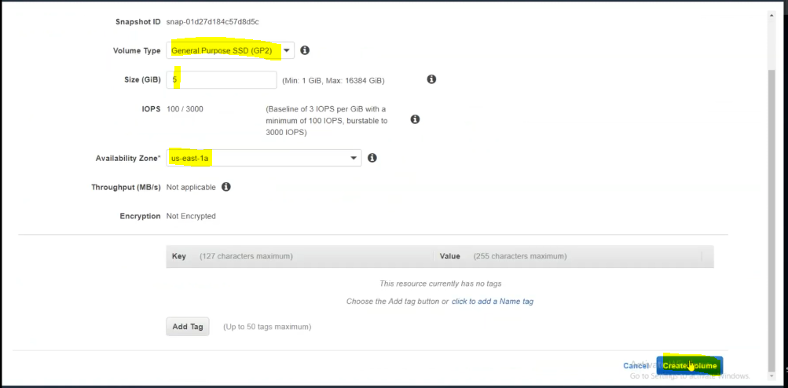

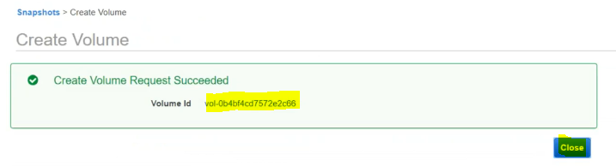

Same again attach volume as fallows.

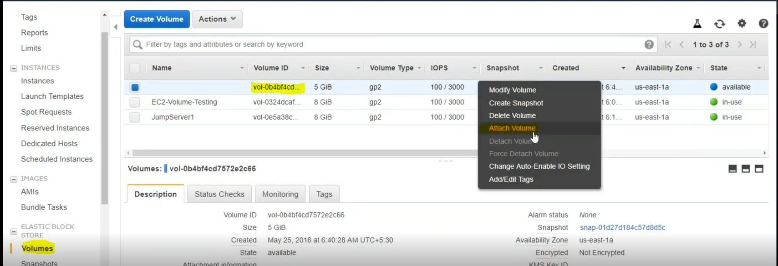

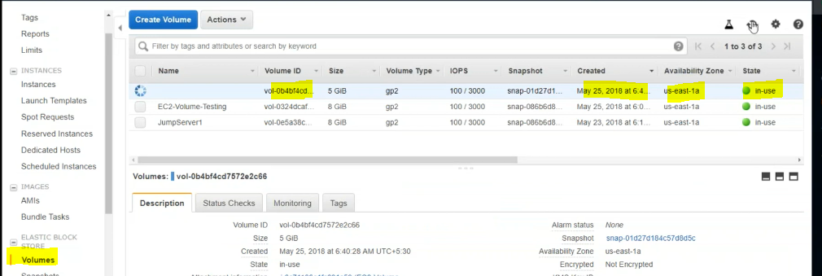

If the same data you need in another location means

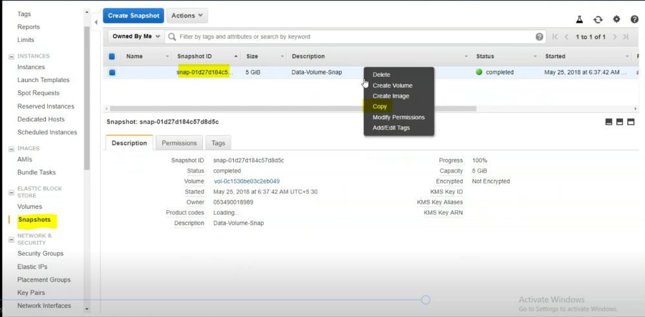

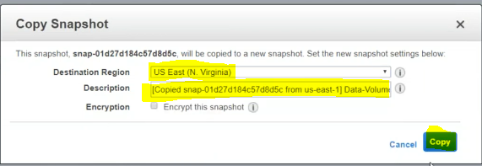

Snapshots are cascading state.

For suppose if you have 5 snapshots first is connected to second ,second is connected to third like this way all snapshots are connected.

We don’t delete one specific snapshot.

For better understanding of snapshots go for



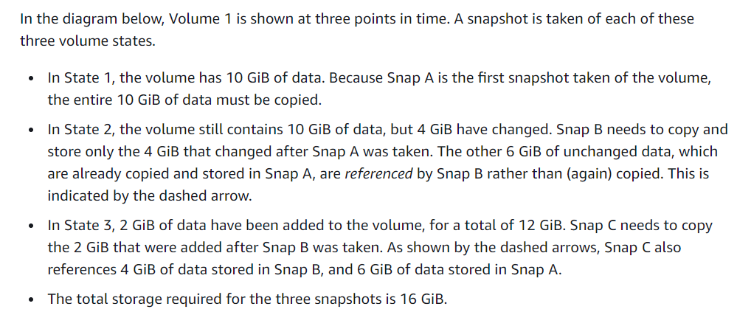

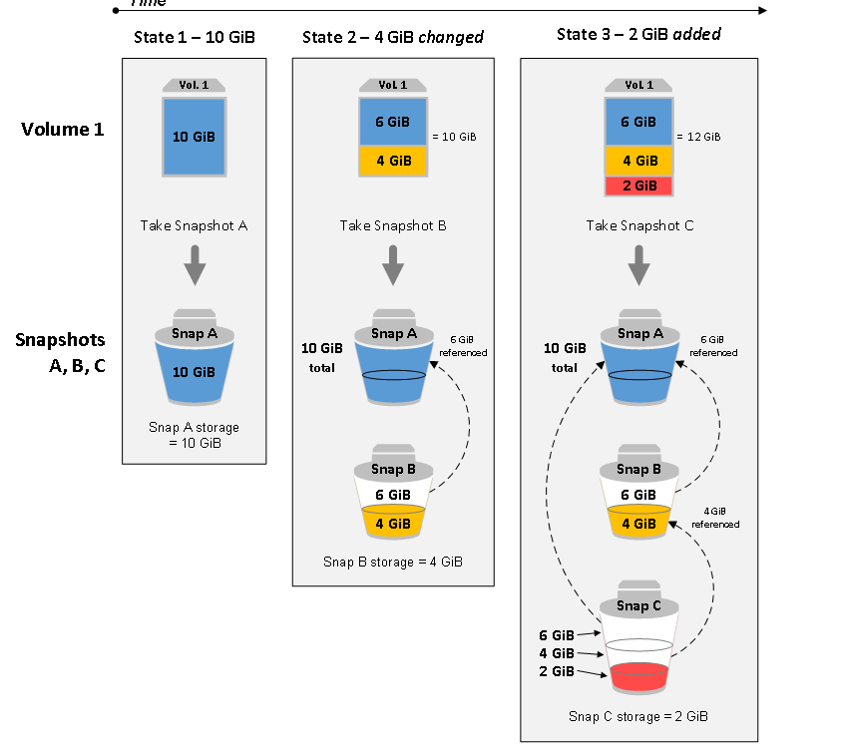

Detach the volume

First unmount he volume



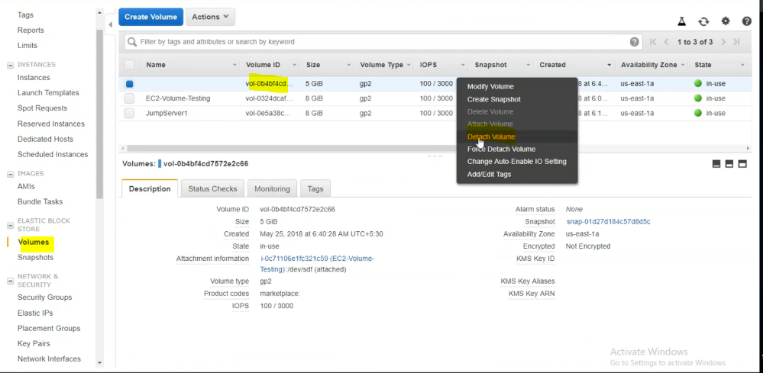

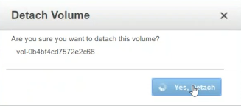

Delete the snapshot

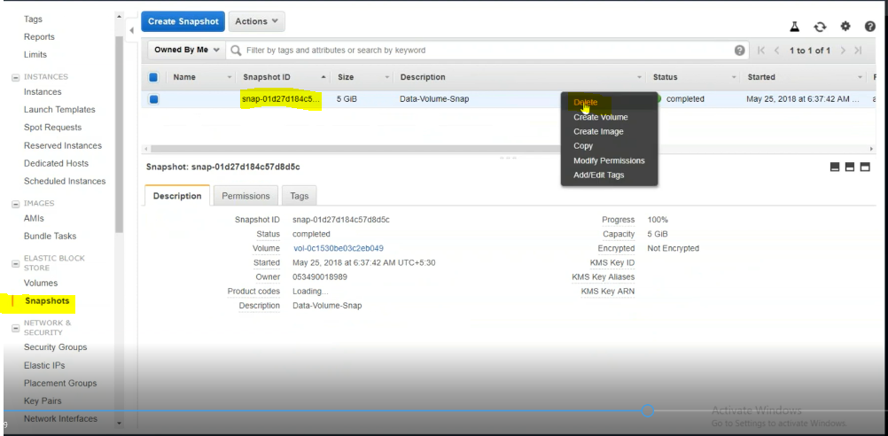

Finally after completion terminate the instance.